

**NOTE**: We know that the easiest way for you to learn how to build your own website is with **real-life examples**. So we decided to create an actual website (using a fake job seeker or "avatar") that you can model your site after AND have access to **24/7/365**.

You can always refer to it at: [**http://jimcanlon.com**](http://jimcanlon.com)

1. Click Here to access our article “**How To Set Up Your Wix Personal Website In Under 15 Minutes**”.
2. Go to **Step One** and watch the video “**How To See If My Domain Name Is Available**”
3. Click the link directly under the video that says [**Click Here to See If My Personal Domain Name Is Available**](http://theinterviewguys.com/godaddy). A new window will pop-up, and you will be on the [**GoDaddy site**](http://theinterviewguys.com/godaddy). **(Remember, if you don’t click this specific link on our page you won’t get the crazy deal (99 cents!) that we found for you!)**
4. In the search bar, type in “[**yourname.com**](http://yourname.com)” to see if your domain name is available. If it isn’t, try a variation of what you just typed using either a **hyphen**, **middle initial** or **middle name**, or a “**.net**” domain extension.

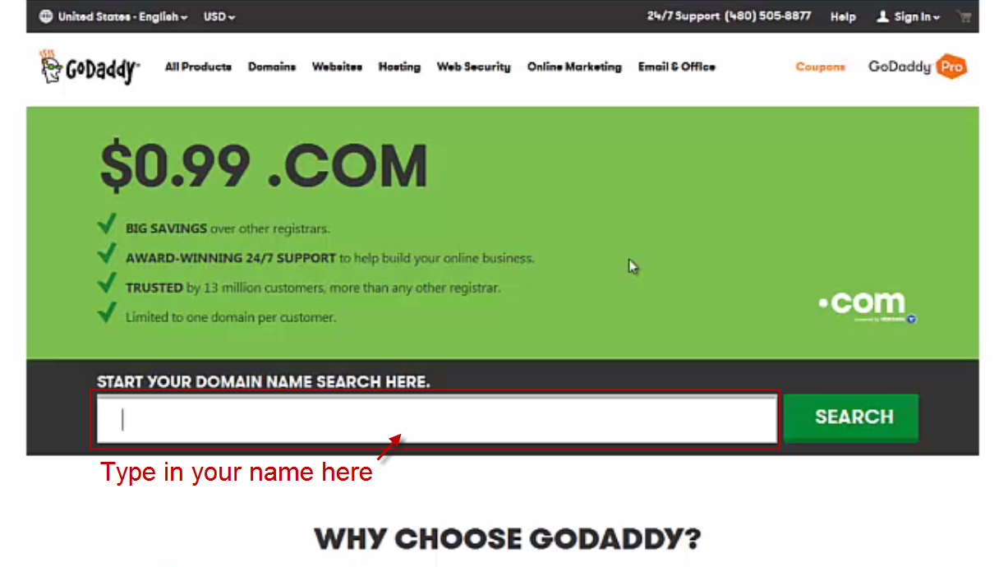

Once you have settled on a domain that you like AND it is available, click the **big “Select” button** to the right of your domain name, and then click **“Continue to Cart”.**

1. Change the amount of years that you are securing your domain for by clicking on the drop-down menu. **In our opinion, you only need to secure your domain for 1 year.** If you’d like to add more years, go ahead.

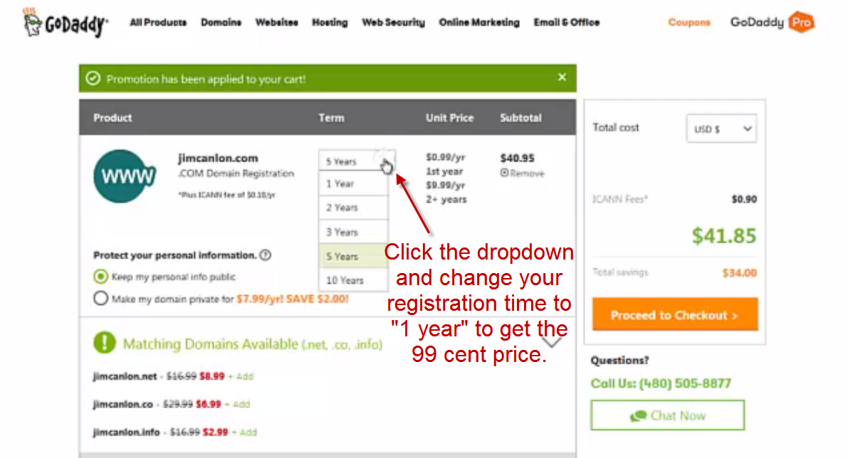

1. Click “**Proceed to Checkout**” and then click “**New Customer**” to create a Godaddy account if you don’t already have one. Fill out all of the requested information and submit it to get your account created.

**Pro Tip**: Create a **new email address** that you use solely for your website (ex. [yournamewebsite@gmail.com](mailto:yournamewebsite@gmail.com)) so you can keep everything organized and separate from your personal email.

1. After your account is open, fill out the payment information for your new domain. **Click continue.**
2. Make sure all of your details are correct and then fill out the “captcha” (security) form.
3. **Congrats!** You’ve secured your domain.  **GoDaddy will then email you a few emails that are important that you read.**  One of them **will ask you to verify your domain**, which is important to do so that you can activate it. **Follow the directions in that email and verify your domain now.**
4. **Go to Step 3 below the domain video** and watch our video **“How To Create Your Personal Branding Website in Less than 15 Minutes.”**
5. Click the link below the video that says **“**[**Click Here to Browse the Wix Templates**](http://theinterviewguys.com/browse-templates)**”**
6. Choose a [**Wix template**](http://theinterviewguys.com/browse-templates) that you would like to use. **If you can’t choose a template on your own, we’ve selected three great templates and posted them underneath the video you are watching.**
7. Once you’ve selected a template that you like, click **“Edit this site”** at the top of your screen.

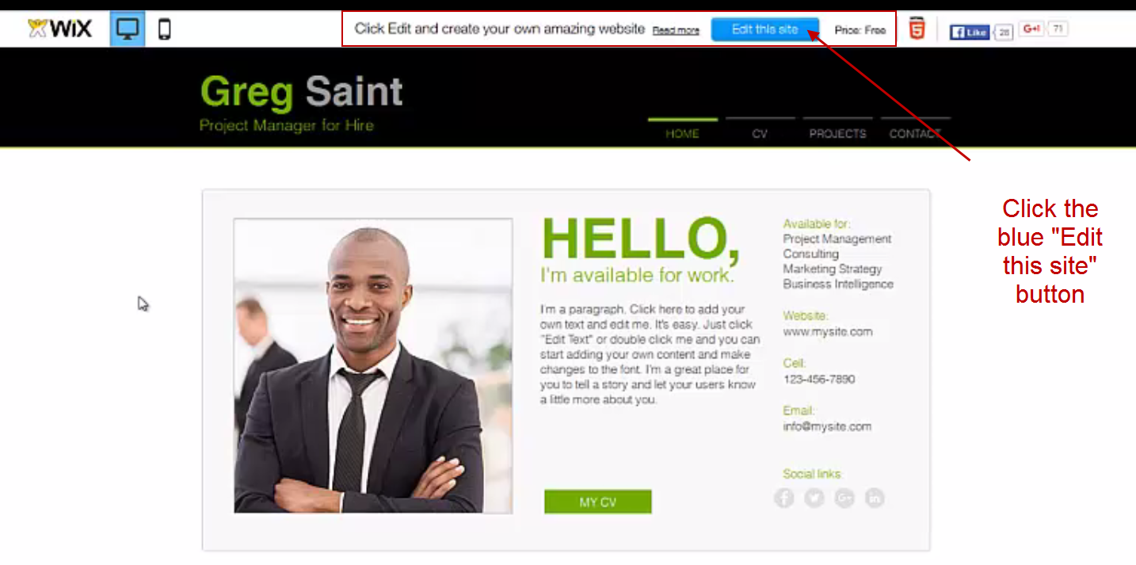

1. Sign up for a Wix account (**you can use the new email address you created above**).
2. Following along with our tutorial in the video, change the name on your template to reflect your name. You can also update any other text that you want to. **(You can change any text by simple “double clicking” on any text. It’s super easy!)**
3. Click the “Pages” button and go to the Resume or CV page on your template. Once you get to that page, copy and paste the information from the Word copy of your resume.

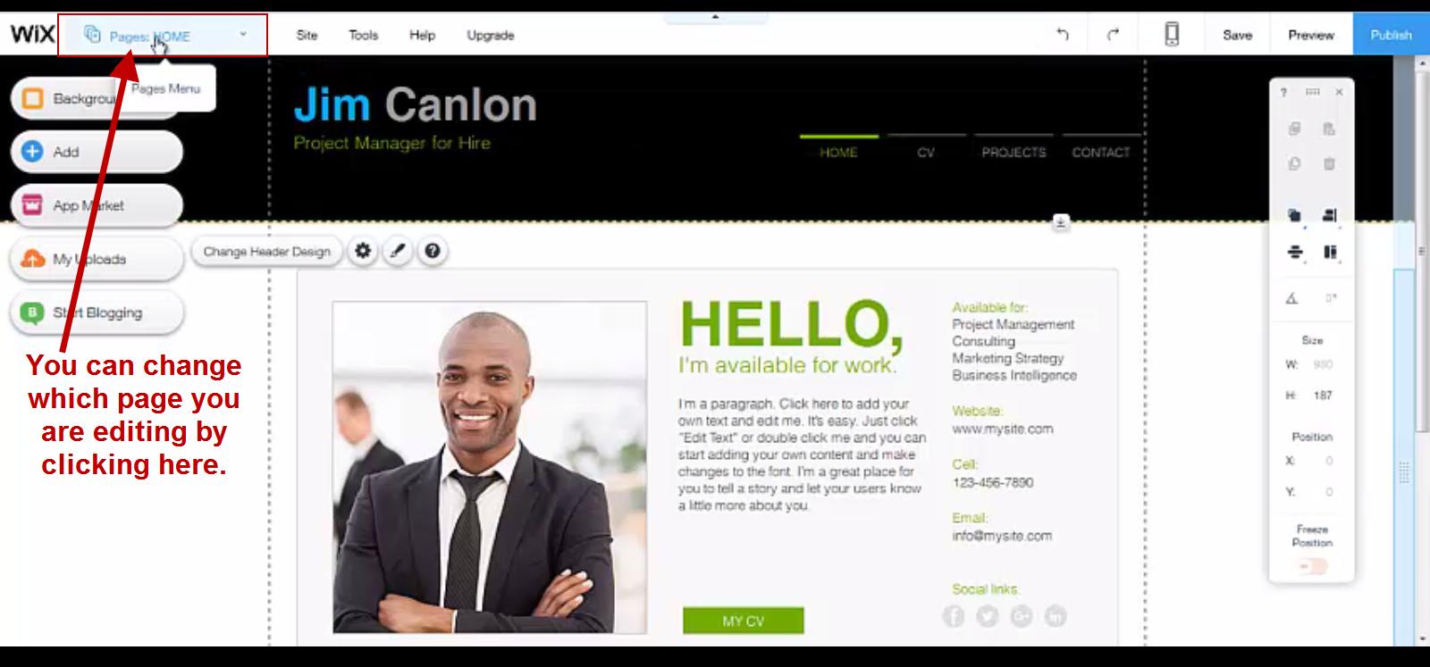

1. Go back to the **Home Page** of your site by clicking the Pages tab. Select the large main image on your template (if there is one) and click “**Change Image**”. (You can also change any images by simply double clicking on them.)
2. Click “**Upload Images**” in the top right corner and locate the picture you want to upload on your computer. Select the picture file you want to upload and click “**Open**”, then click “**Done**” and then “**Choose Image**”.
3. Click “**Preview**” in the top right corner to see how it looks right now.
4. Click “**Back to Editor**” to **begin the process of removing the Wix ads and connecting your domain**.
5. Click the **“Publish” button** in the top right corner.
6. Click **“Connect Your Own Customized Domain”**
7. Click **“Save and Continue”**
8. Click **“Connect a domain you already own”**

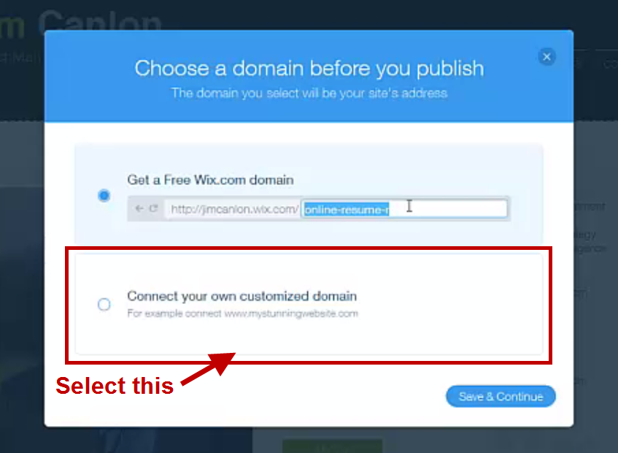

1. **Change the Premium plans from “Yearly” to “Pay Per Month” and select the $12.95 per month option.**

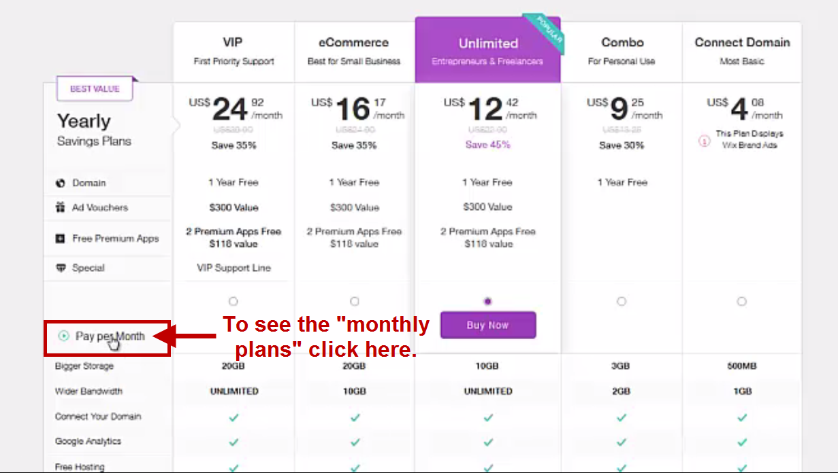

1. Fill out the payment information. Click “Submit Purchase”.
2. Click **“Connect it Now”** to connect your domain.

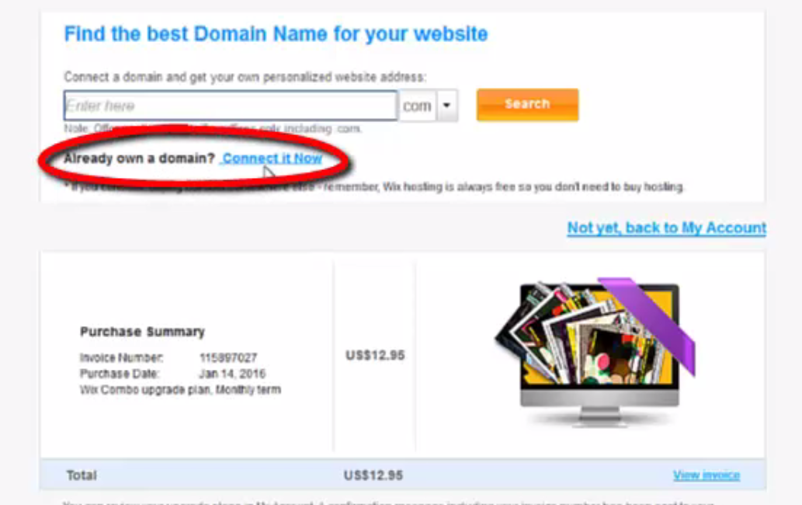

1. **Enter the domain you purchased in Step One.**
2. **In the drop-down menu, select GoDaddy.**

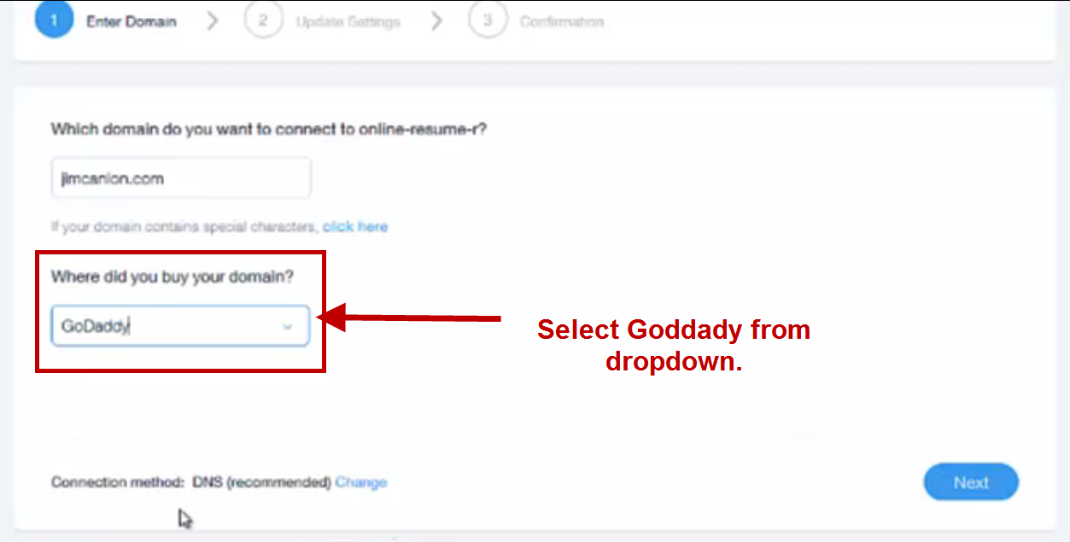

1. Click **“Next”**
2. **Open up a new tab in your browser** and **sign into GoDaddy**. (Tip: you can find your login info in the email they sent you when you bought your domain name in Step 1 of this tutorial.)
3. **Click the “plus sign” next to Domains.**

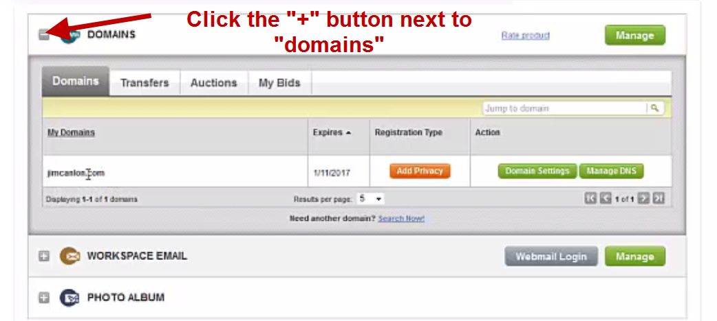

1. Click **“Manage DNS” next to** [**yourname.com**](http://yourname.com)**.**

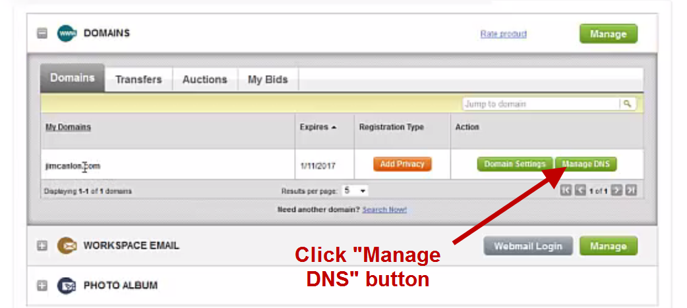

1. Click “**Manage**” under “**name servers**".

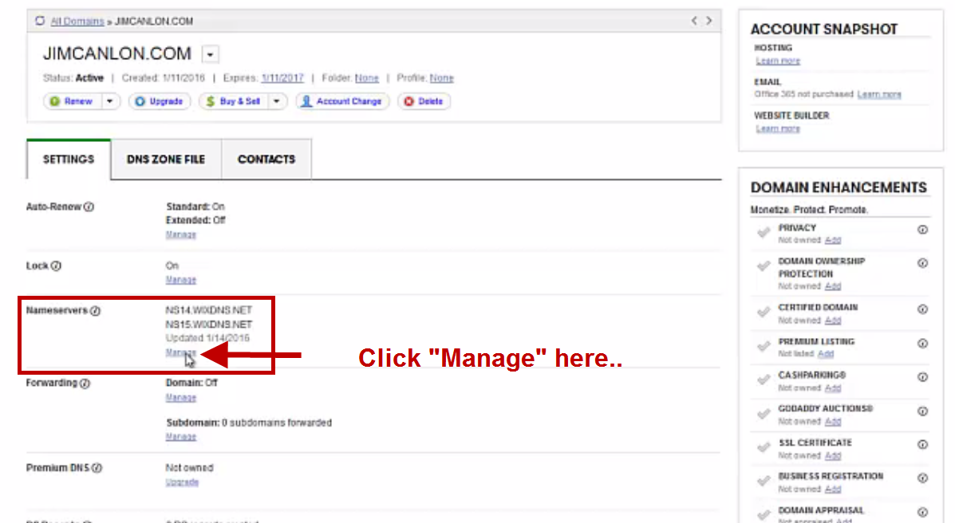

1. Change “**Setup type**” to **custom**.

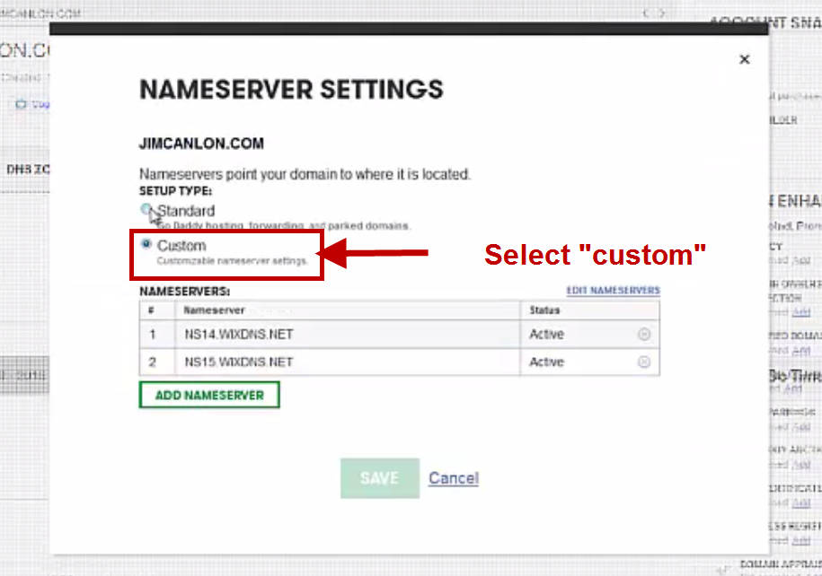

1. Click “**Edit name servers**”
2. **Copy and paste the two name servers “codes” from Wix into the “edit nameservers area and click OK. (The namesever codes can be found back on the WIX Website. NOT ON GODADDY)**

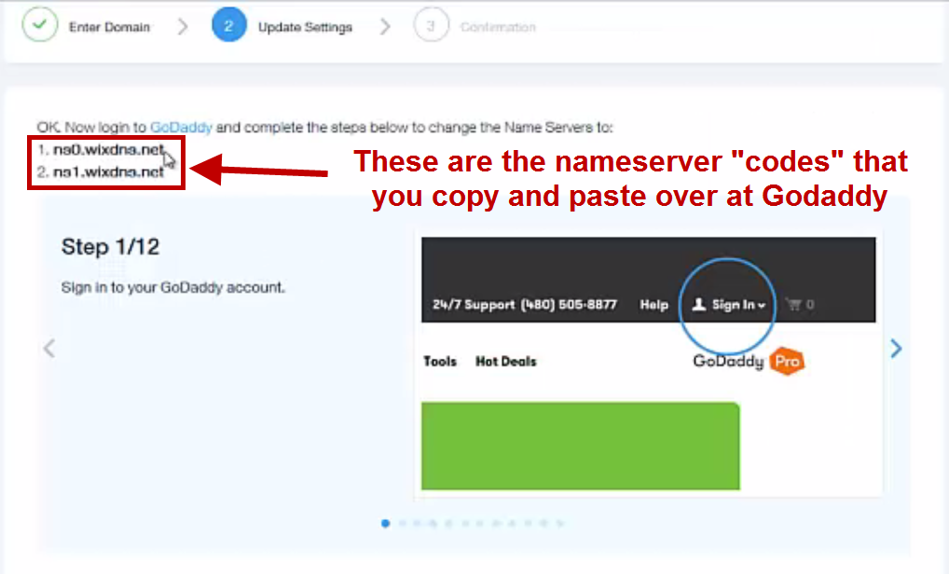

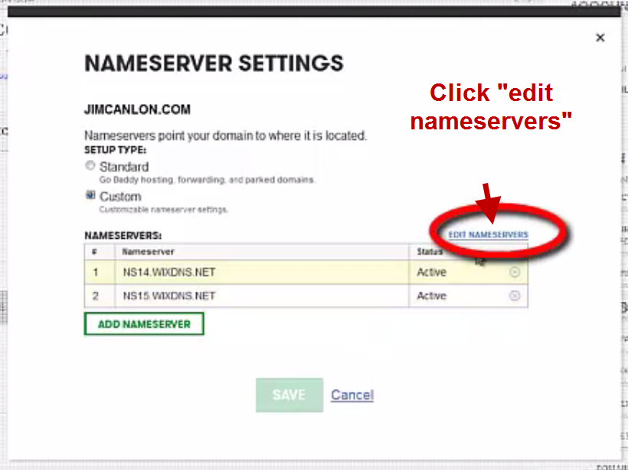

1. Go back to Wix and **cycle through the “help images”**. Click **Next** when you get to the last image.

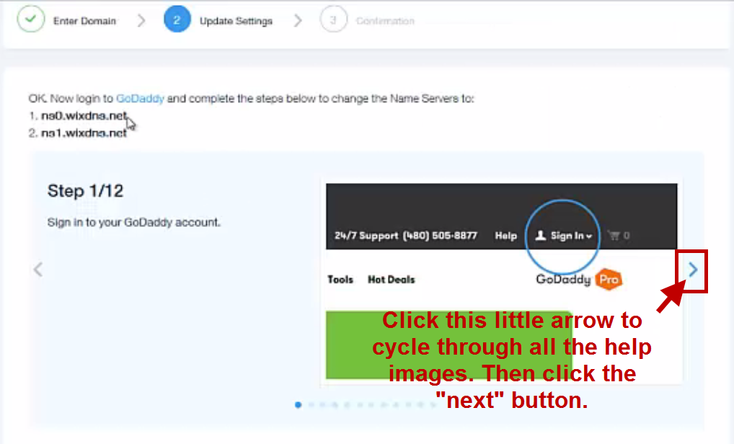

1. **Connect your domain! Congrats!**

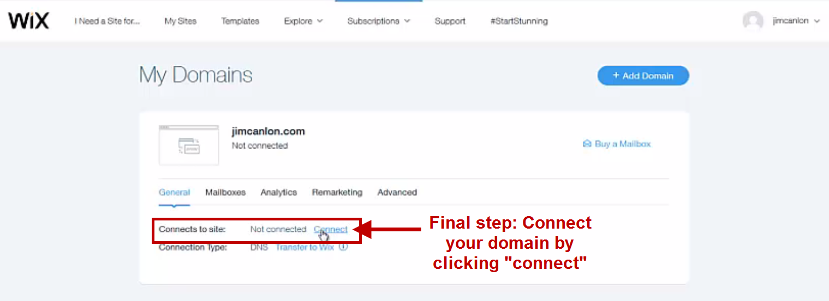

1. **Continue to edit your site as you please.**